Client – FITNESS SF | Industry – Fitness | Location – USA

Enhancing Member Engagement and Conversion with AI Agents

**About the Client**

FITNESS SF, a premier gym chain with eight clubs across San Francisco, is renowned for its state-of-the-art facilities and comprehensive fitness programs. Catering to a tech-savvy demographic in the heart of Silicon Valley, their unwavering commitment to innovation and excellence ensures an unparalleled fitness experience for every member.

**Challenges**

FITNESS SF staff frequently dealt with calls and emails concerning general inquiries, which diverted their attention from more critical tasks. Common questions included:

* High dependency on manual processes for answering FAQs and handling membership inquiries.
* Inefficiencies in class bookings and personal training appointments, leading to missed opportunities.
* Member retention concerns, as the gym lacked predictive analytics to identify and engage at-risk members proactively.

Delivering an exceptional web experience was crucial, as nearly one-third of their online prospects joined without ever visiting the gym in person.

**What We Did**

* **Data Analysis:** Conducted a comprehensive analysis of FITNESS SF ‘s existing engagement processes to identify areas for improvement.
* **Customized AI Solution:** Designed the Member Concierge AI Agent, named Cardi-O. This agent was pre-trained to align with FITNESS SF‘s specific requirements and embody the brand’s voice.

**SOLUTION**

To address these challenges, Fitness SF implemented Agentic AI-powered Cardi.O chatbot, an intelligent conversational assistant designed to deliver seamless, omnichannel member support. Unlike traditional chatbots, Agentic AI enables personalized, real-time engagement with gym members.

**Conversational AI for 24/7 Member Engagement**

* Provides instant responses to FAQs about locations, class schedules, and membership options.
* Automates responses across multiple touchpoints, including web and mobile.

**AI-Powered Membership Assistance**

* Guides users through gym sign-ups, membership renewals, and plan upgrades.
* Simplifies onboarding with automated step-by-step assistance.

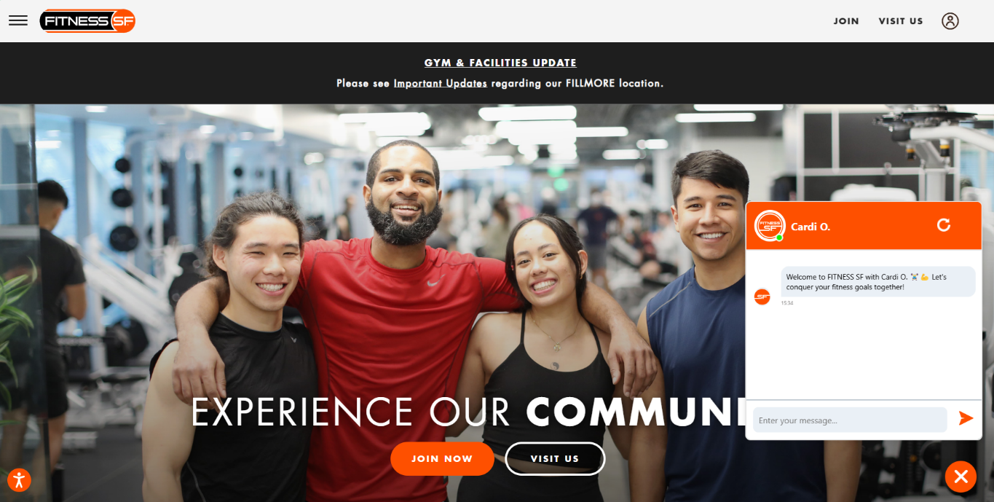

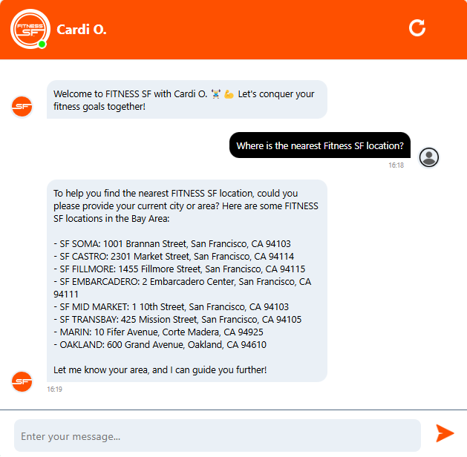 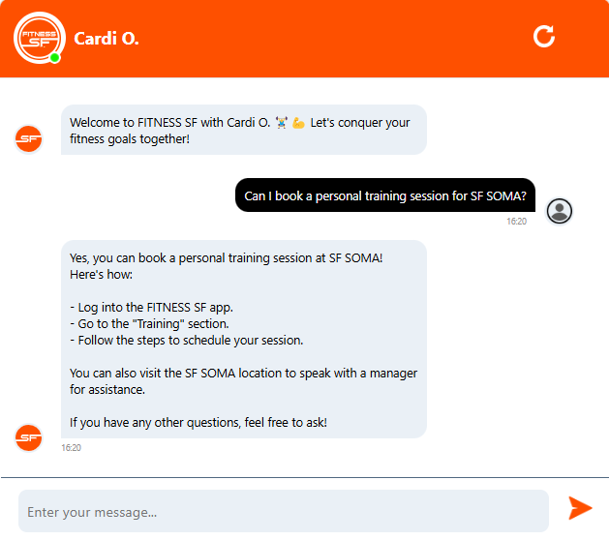

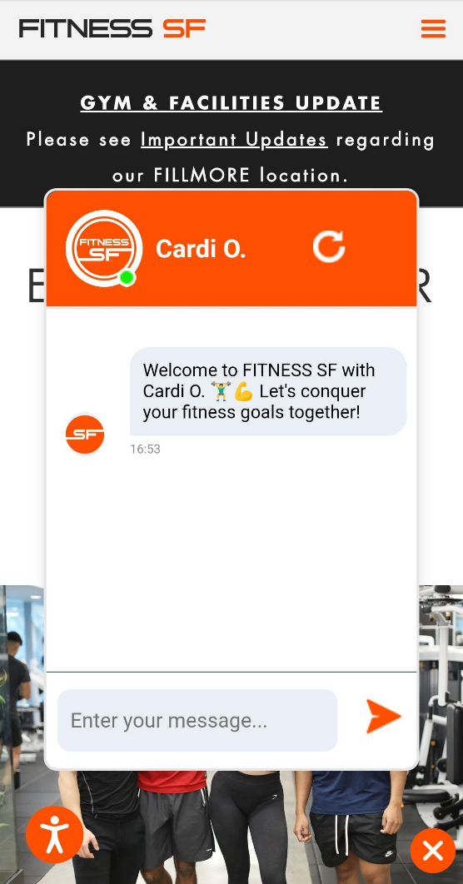

**Don Dickerson, Vice President, Fitness SF**

https://www.youtube.com/watch?v=SGfvr8hgSWA

**Scalability & AI Evolution**

The Agentic AI chatbot continuously learns from user interactions, refining its responses over time. This enables Fitness SF to scale AI-powered engagement effortlessly as their member needs evolve.

* Adaptive AI ensures more accurate and relevant responses with each interaction.
* Real-time data analysis enhances personalization, making interactions feel human-like and intuitive.

**Security & Compliance**

Fitness SF’s AI adoption aligns with strict data security and compliance protocols, ensuring safe and responsible AI usage.

* End-to-End Encryption protects member data and transactions.
* Role-Based Access Control (RBAC) limits data exposure to authorized personnel only.
* GDPR & CCPA Compliance safeguards personal information and ensures ethical AI usage.

**Benefits & Outcomes:**

* **Enhanced Efficiency:** Significant reduction in the time spent on general membership inquiries, saving roughly 20 hours each month.
* **Resource Allocation:** The efficiency boost allows FitnessSF to allocate more resources to member satisfaction and operational improvements.
* **Improved Engagement:** Personalized interactions lead to better engagement and higher conversion rates.
* **An Extension of the Fitness SF Team, Not Just Software:** Maintains personalized, human-like interactions, feels like a real team member, freeing staff to prioritize engagement and operations.

Since integrating DXFactor’s AI-powered agent, we’ve saved thousands of hours in front desk time over the year. It’s like hiring a full-time team member who never sleeps. That freed up our staff to focus on what really matters — our members.

– Troy MacFarland, Director of Marketing, FITNESS SF

**KEY HIGHLIGHTS**

**4,000 hours**

Annual Time Savings

**Resource Reallocation**

Focus on member satisfaction

**Higher Conversion Rates**

Better personalized engagement